Lab4 -> Assume Role

* Remove policy from the user

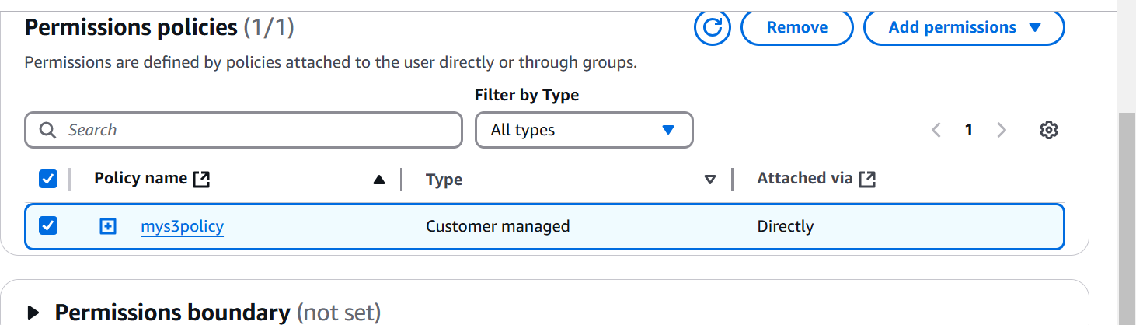

Create Role

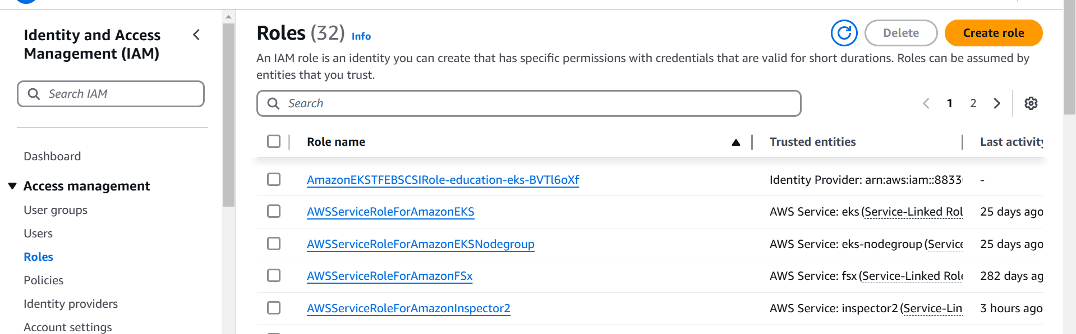

Select option -> AWS account

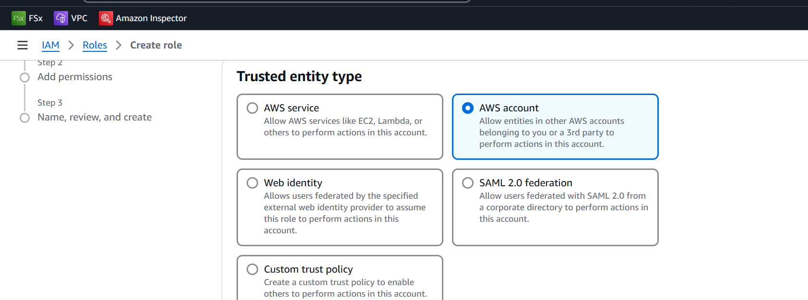

Press next

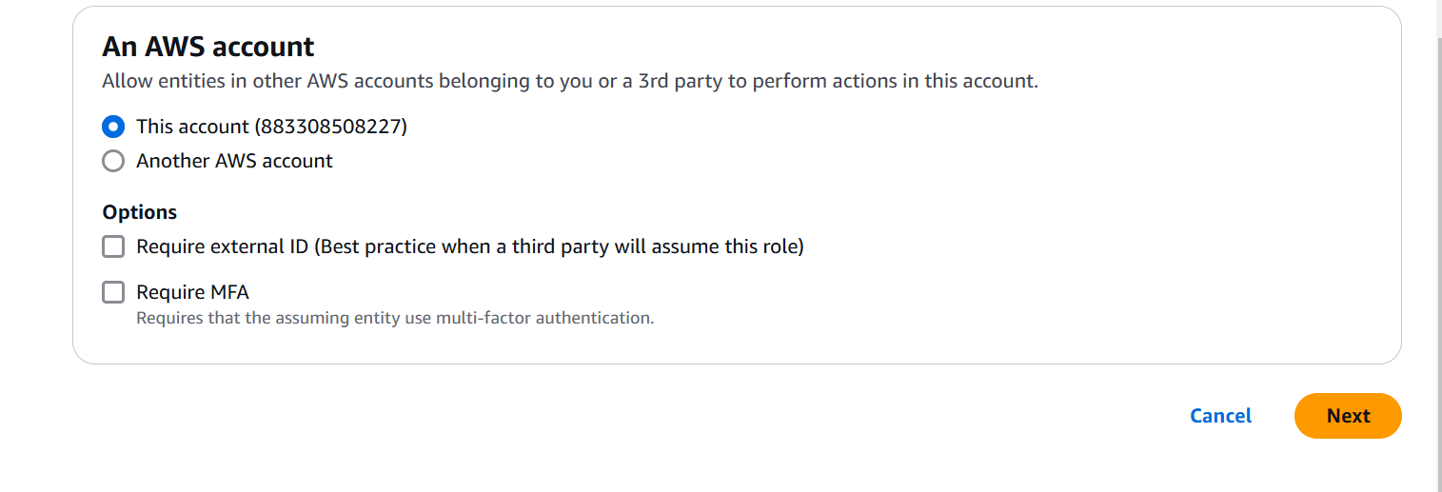

Select Add permission

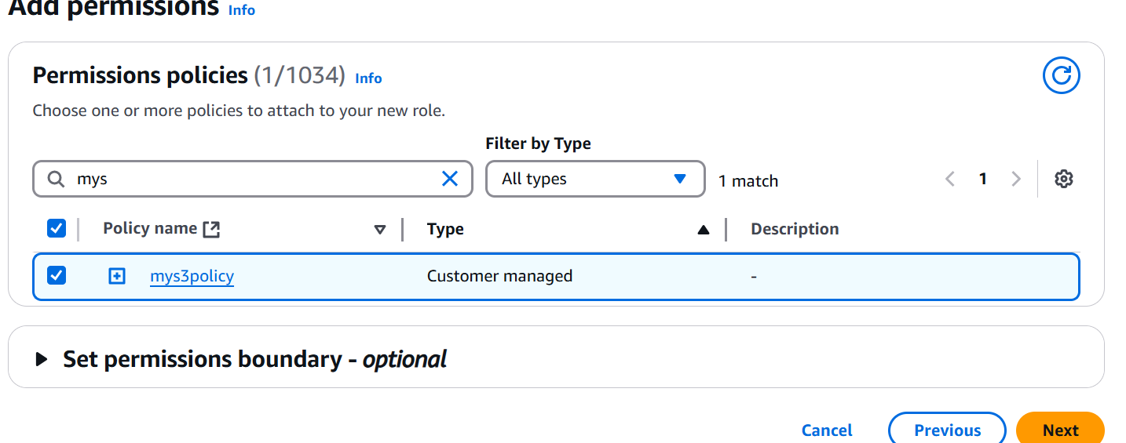

Provide role name

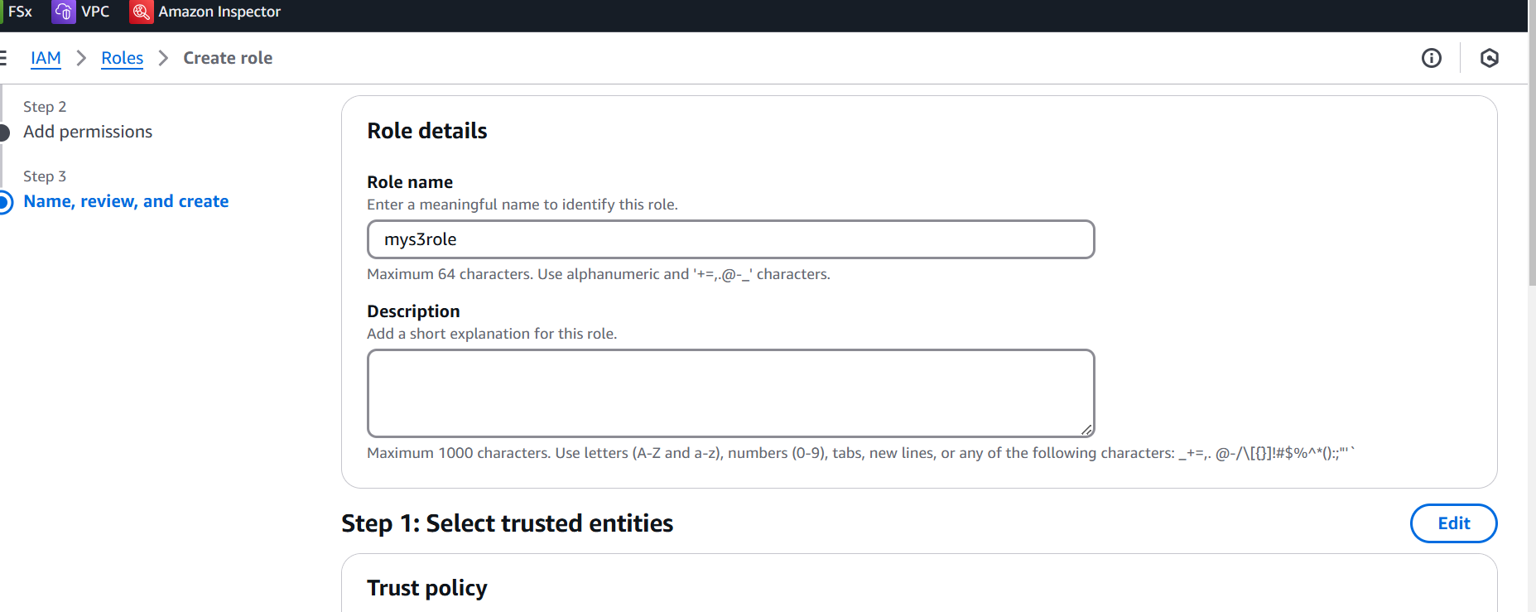

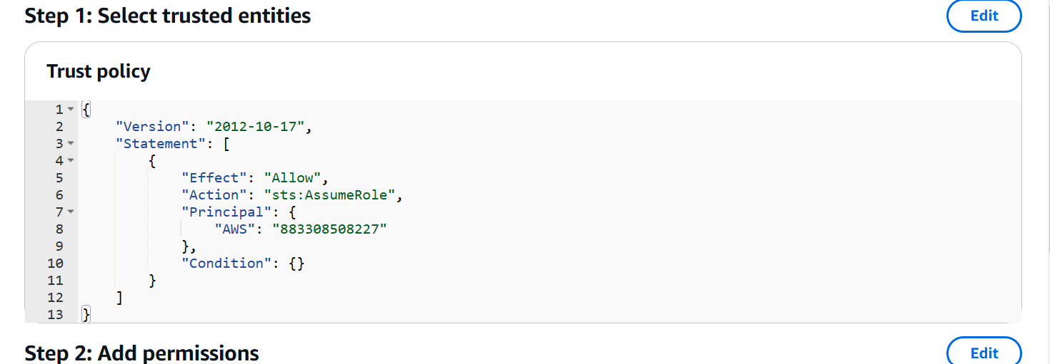

Create role

Note down the arn of IAM role

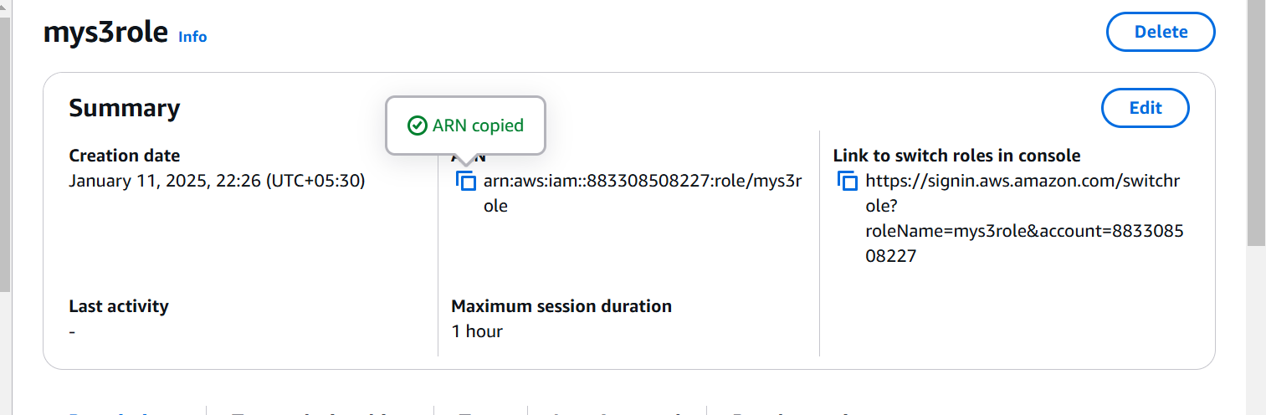

Go to your user🡪 testuser

Create inline policy

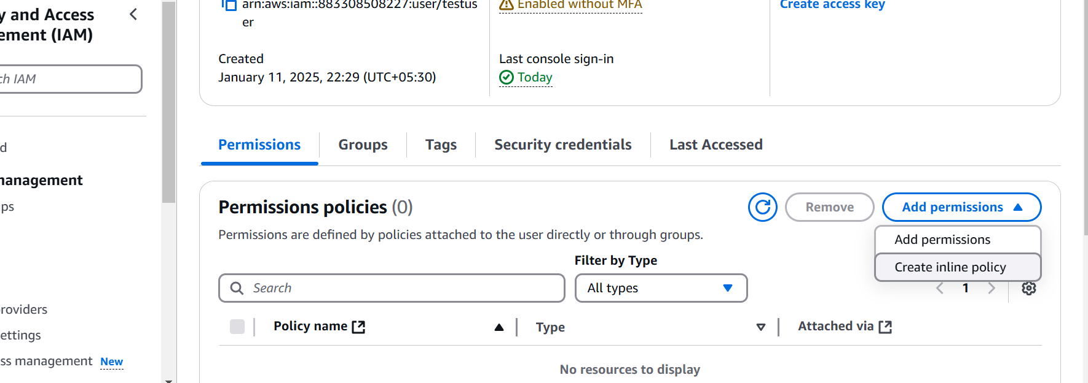

In policy check for STS and action search for assume role

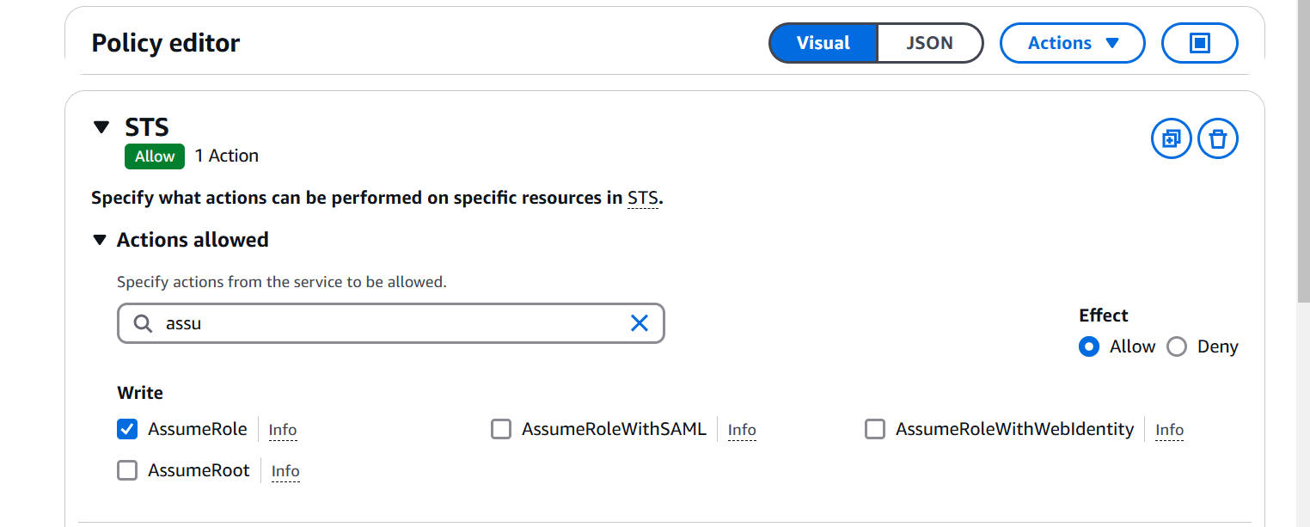

Provide role ARN

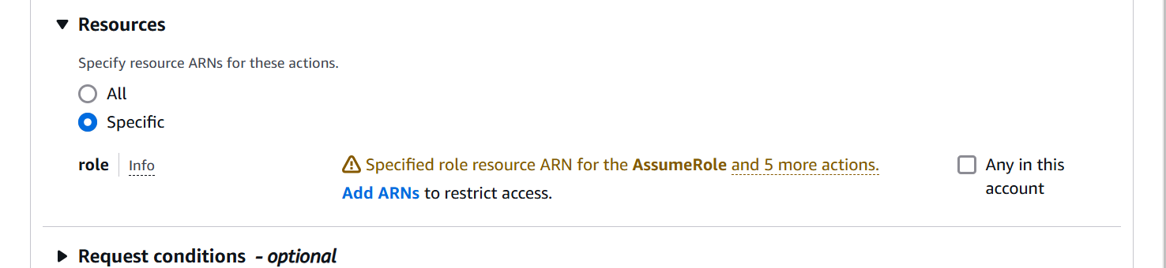

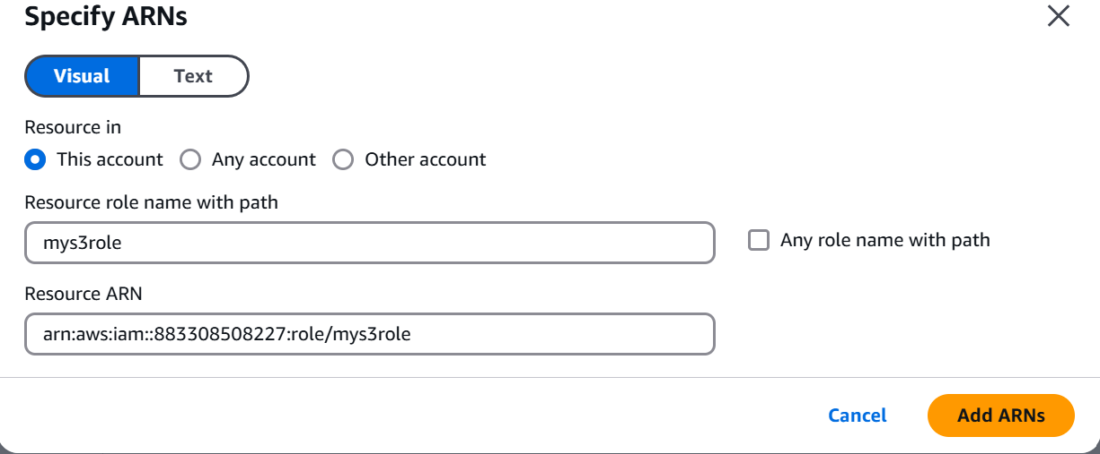

JSON

{

"Version": "2012-10-17",

"Statement": [

{

"Sid": "VisualEditor0",

"Effect": "Allow",

"Action": "sts:AssumeRole",

"Resource": "arn:aws:iam::883308508227:role/mys3role"

}

]

}

Provide name and create

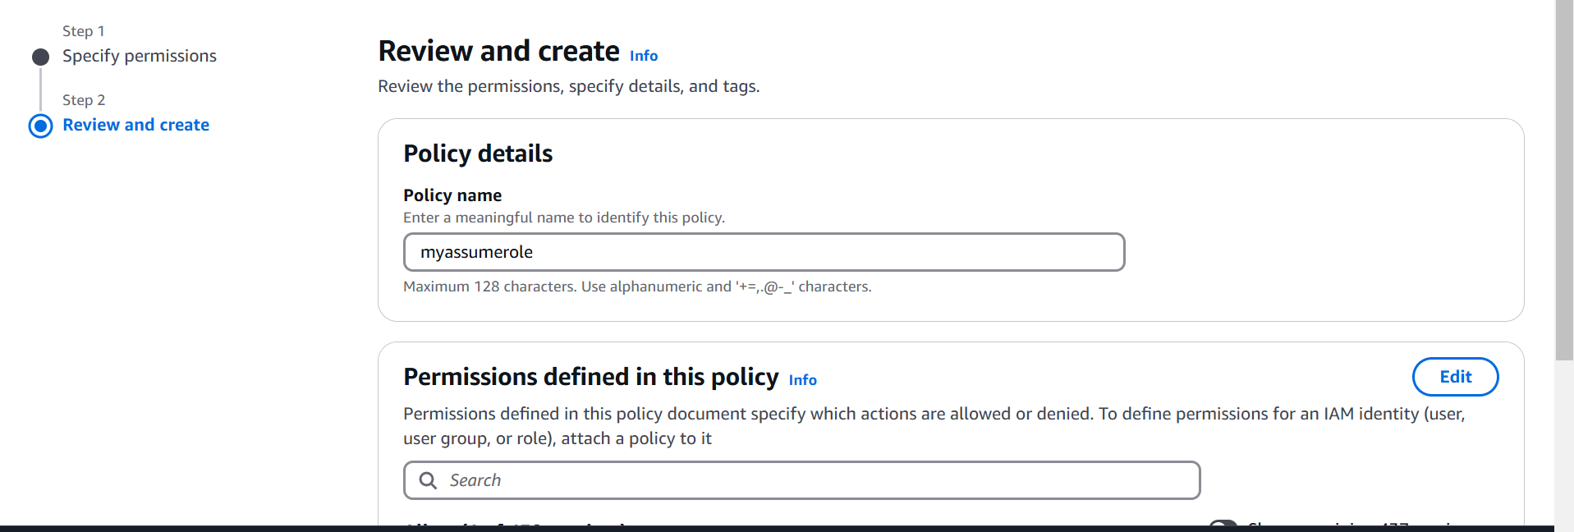

Check the option to switch the role: Link to switch the role

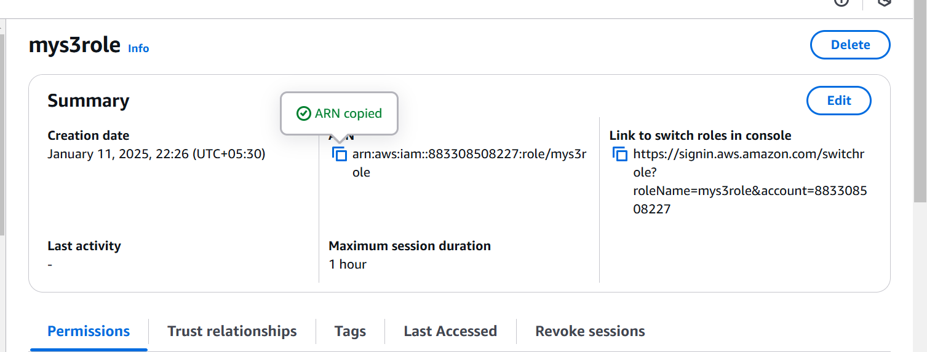

Switch Role

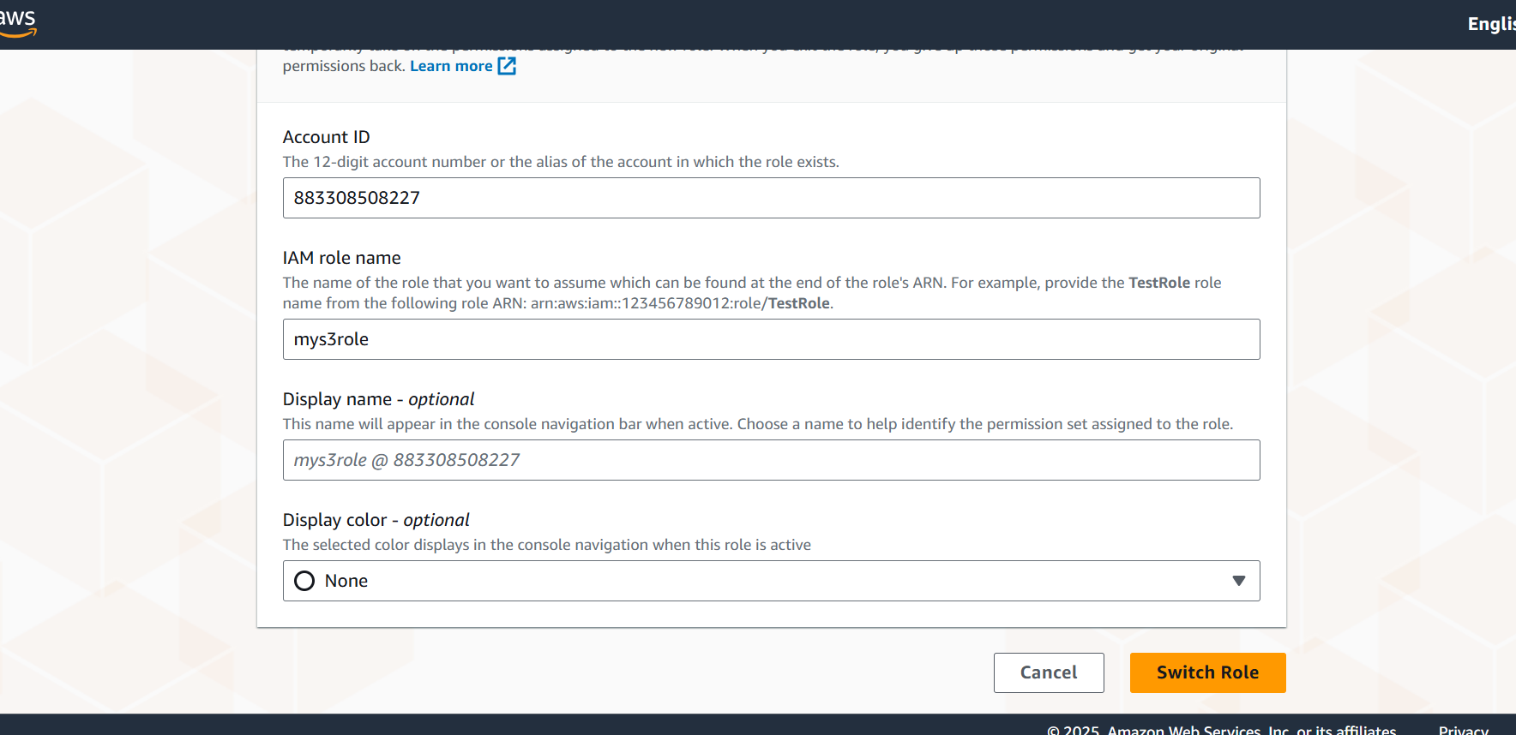

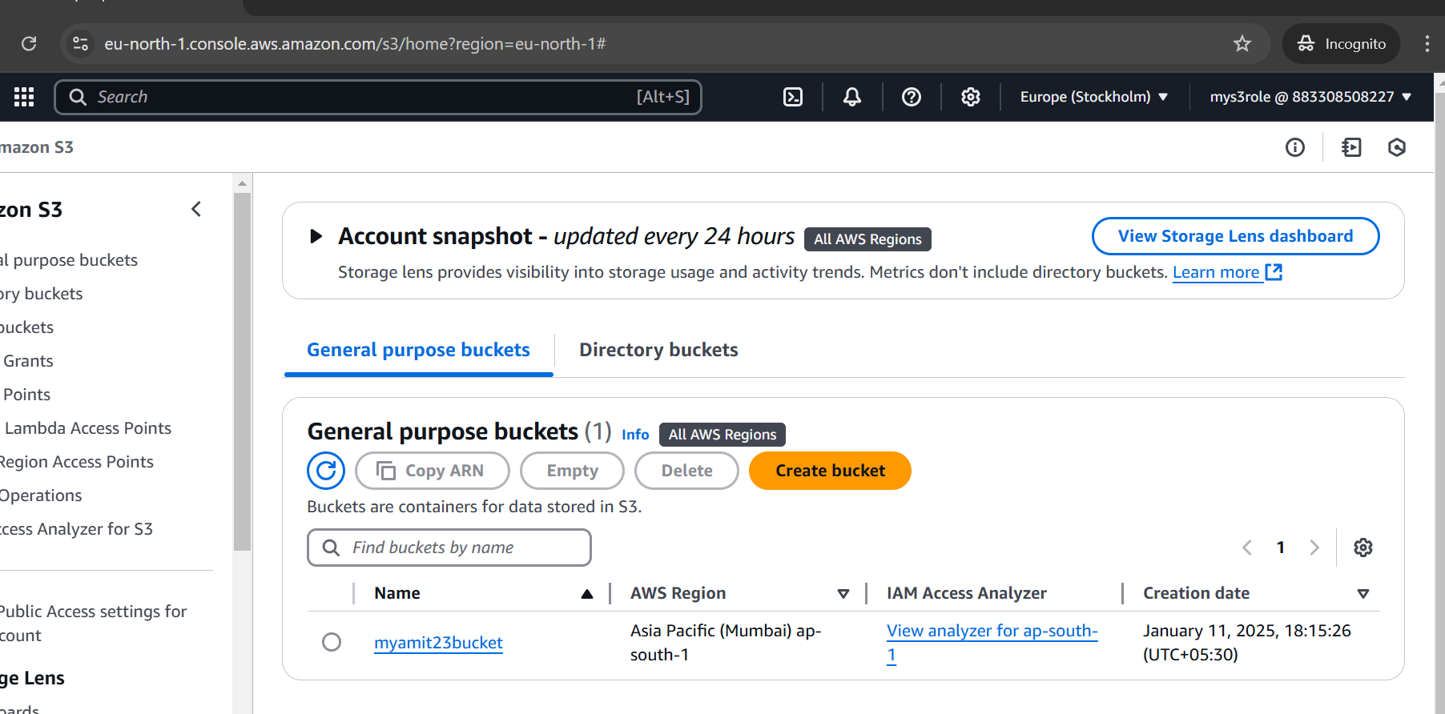

Click on the role and switch back

